**SOCIAL NETWORKING WEBSITES**

1. Once information is posted to a social networking site, it is no longer private. The more information you post, the more vulnerable you may become. Even when using high security settings, friends or websites may inadvertently leak your information [1].
2. Social Networking can have the following consequences for an organization [2]:

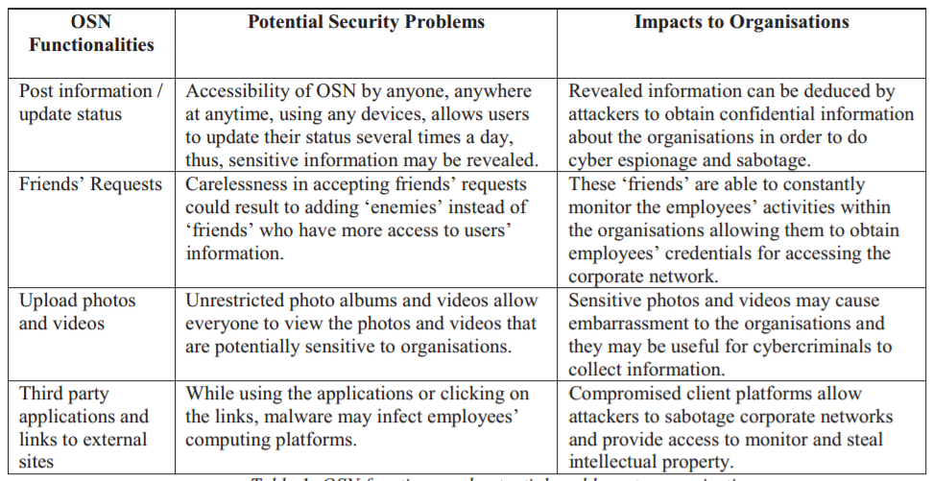

*OSN= Online Social Networking

1. Disclosing personal information online is a double-edged sword. Information exposure is usually a plus, even a must, if people want to join certain types of social communities; however, leakage of personal information, especially one’s identity, may invite malicious attacks from the real world and cyberspace. Many studies have addressed the problems of privacy invasion and security threats raised by information exposure online, e.g., stalking, reputation slander, personalized spamming and phishing [3].

**REFERENCES**

1. <https://www.fbi.gov/file-repository/internet-social-networking-risks-1.pdf>
2. <http://ro.ecu.edu.au/cgi/viewcontent.cgi?article=1092&context=ism>
3. <http://rdcu.be/skod>